**RESUME** 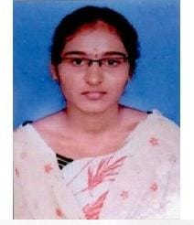

Name : G Munirathnamma

Father’s Name : G Sreeramulu

Mobile :9502830442

Email id :naniammu302@gmail.com

Gender : Female Date of Birth : 02-06-1994

Marital Status : Married Religion : Hindu

Nationality :Indian Languages Known :Telugu, English

**Educational Qualifications**

|  |  |  |  |
| --- | --- | --- | --- |
| S No | Institute Name | Year of Passing | Marks Percentage |
| 1 | ZP High School, Kothapalli (10 Class) | 2010 | 50% |
| 2 | TKC Govt. Jr College,Palamaner, (Intermediate) | 2012 | 60% |
| 3 | SVCR Govt. Degree College, Palamanar | 2015 | 64% |
| 4 | Sri Venkateswara Universuty | 2022 | 79% |
| 5 | Sri Venkateswara University, Tirupati | 2017 | 66% |

**Experience**

|  |  |  |  |
| --- | --- | --- | --- |
| S No | Name of the College/Institution | Position | Working Period |
| 1 | Kasturba Gandhi Balikala Vidyalaya, Gangavaram | Junior Lecturer | 2 Years |
| 2 | Sri Vani Degree College, Palamaner | Lecturer | 2 Years |
| 3 | SVCR Govt. Degree College, Palamanar | Lecturer | 1 Year |

Declaration

I hereby declare that the information provided here is true to the best of my knowledge.

Place : Palamaner

Date : 25-07-2024

Signature